

Reset Password Verifikasi Email Firebase Auth

Pemrograman Mobile II

**Reset Password**

1. Buat module baru dengan mengetikan perintah di terminal vscode

get create page:reset_password

1. Edit file **login_view.dart** di folder lib/app/modules/login/views,tambahkan code sebagai berikut.

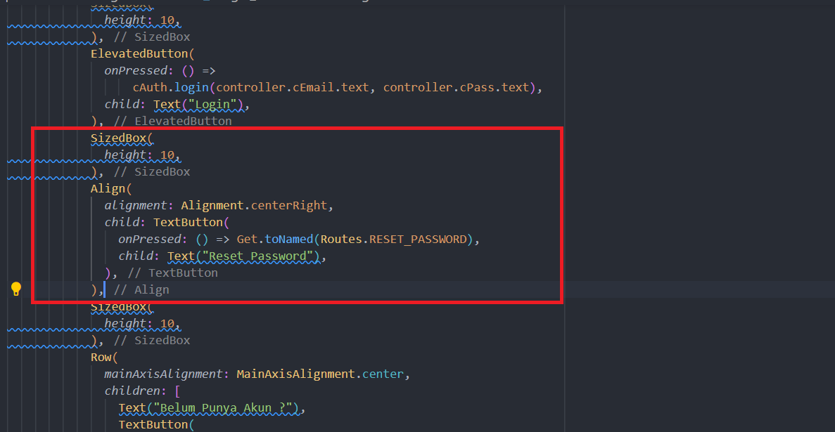

1. Buka file **auth_controller.dart** didalam forlder lib/app/controllers, ubah code **void resetPassword() {}** menjadi

void resetPassword(String email) async {

if (email != "" && GetUtils.isEmail(email)) {

try {

await auth.sendPasswordResetEmail(email: email);

Get.defaultDialog(

title: "Berhasil",

middleText: "Kami telah mengirimkan reset password ke $email",

onConfirm: () {

Get.back();

Get.back();

},

textConfirm: "OK",

);

} catch (e) {

Get.defaultDialog(

title: "Terjadi kesalahan",

middleText: "Tidak dapat melakukan reset password.");

}

} else {

Get.defaultDialog(

title: "Terjadi kesalahan", middleText: "Email tidak valid");

}

}

1. Buka file **reset_password_view.dart** di folder lib/app/modules/reset_password/views, paste code berikut

import 'package:flutter/material.dart';

import 'package:get/get.dart';

import 'package:bcdx_11312136/app/routes/app_pages.dart';

import '../../../controllers/auth_controller.dart';

import '../controllers/reset_password_controller.dart';

class ResetPasswordView extends GetView<ResetPasswordController> {

final cEmail = TextEditingController();

final cPass = TextEditingController();

final cAuth = Get.find<AuthController>();

@override

Widget build(BuildContext context) {

return Scaffold(

appBar: AppBar(

title: const Text('Reset Password'),

centerTitle: true,

),

body: Container(

padding: EdgeInsets.all(10),

child: ListView(

children: [

TextField(

controller: cEmail,

decoration: InputDecoration(

labelText: "Email",

),

),

SizedBox(

height: 20,

),

ElevatedButton(

onPressed: () => cAuth.resetPassword(cEmail.text),

child: Text("Reset Password"),

),

SizedBox(

height: 10,

),

Row(

mainAxisAlignment: MainAxisAlignment.center,

children: [

Text("Sudah Punya Akun ?"),

TextButton(

onPressed: () => Get.toNamed(Routes.LOGIN),

child: Text("Klik Disini"),

)

],

),

],

),

),

);

}

}